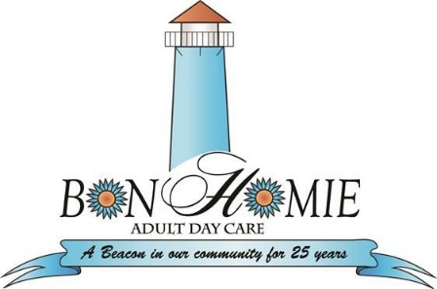

Bon Homie Adult Day Center is expanding its services. With 28 years of experience in providing care and support to seniors and disabled adults in the Limerick and surrounding communities we are growing our offerings to include Concierge services.
Simpler Days concierge services are available to professionals, caregivers, and individuals that need assistance in meeting their own needs or those that depend on them.

Simpler Days Concierge services include:
Transportation to appointments. Accompany individuals on scheduled appointments. Drop off and pick up dry cleaning. Merchandise purchases and returns Gift shopping. Grocery shopping. Prescription pickups. Post office pick-ups, purchasing of stamps. Meal preparation. Special diet delivery (puree, fine chopped and mechanical soft). Gourmet meal delivery.

If you are interested in acquiring our concierge services, please contact us at bonhomieadc@comcast.net or call the center at (610) 792-8800.

